Statistics

ITDEV – 117 - Assignment #5

Submitted by Arun Kumar Kanakasabai

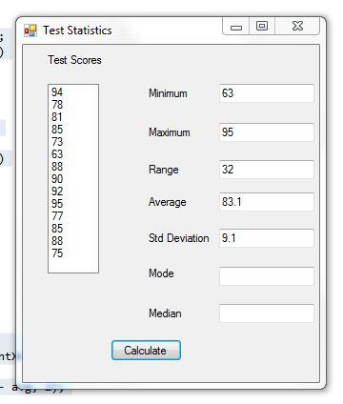

using System;

using System.Collections.Generic;

using System.ComponentModel;

using System.Data;

using System.Drawing;

using System.Linq;

using System.Text;

using System.Threading.Tasks;

using System.Windows.Forms;

namespace ITDEV117_Assignment5

{

public partial class Form1 : Form

{

public Form1()

{

InitializeComponent();

}

private void btnCalculate_Click(object sender, EventArgs e)

{

double val, total, avg, devn; //declaring variables

int count = this.listBox1.Items.Count;

int intX;

total = 0;

//Average calculation

for (intX = 0; intX < count; intX++)

{

val = Convert.ToDouble(this.listBox1.Items[intX].ToString());

total = total + val;

}

avg = Math.Round(total / count, 1); //average calculation to one decimal place

this.txtAvg.Text = avg.ToString(); //sending the average value to text box

//Maximum, minimum and range calculation

int[] numbers = new int[listBox1.Items.Count];

for (int i = 0; i < listBox1.Items.Count; i++)

{

object ret = listBox1.Items[i];

numbers[i] = Convert.ToInt16(ret);

}

int min = numbers[0]; //variable declaration

int max = numbers[0];

for (int i = 0; i < listBox1.Items.Count; i++)

{

if (min > numbers[i]) min = numbers[i];

if (max < numbers[i]) max = numbers[i];

}

this.txtMax.Text = max.ToString();

this.txtMin.Text = min.ToString();

int range = max - min; //range calculation

this.txtRange.Text = range.ToString();

//Standard deviation calulation

double dtotal = 0; //variable declaration

for (intX = 0; intX < listBox1.Items.Count; intX++)

{

dtotal = dtotal + Math.Pow(numbers[intX] - avg, 2);

}

devn = Math.Round(Math.Sqrt(dtotal / (count - 1)), 1);

this.txtStdDeviation.Text = devn.ToString();

}

}

}